**Calibration Plots**

Calibration plots is used to check whether model needs calibration or not.

For this plot there is steps :

Suppose we train a model f using training data Dtr

Now using that model f we predict output(this is probability from that model) of cross validation data Dcv as shown in below fig.

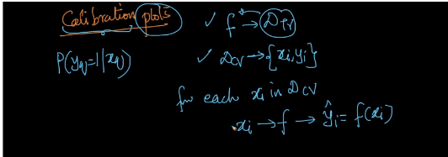

1. Now first we build a table cv data

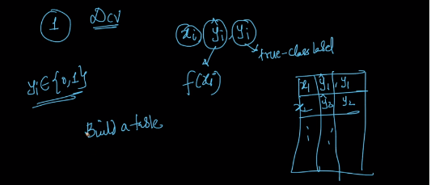

1. We sort this table in increasing order of predicted value yi^

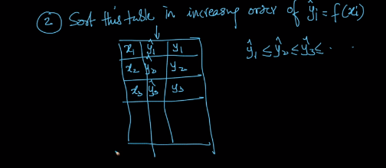

1. Now we create a chunks of size m = 100 suppose we have 10k pts in Dcv so therefore we got 100 chunks of size 100

Now we calculate a avg of yi^ and yi for each chunk and it is represented as y^(j) ­and y(j) ­­here j is chunk number.

Now suppose there is 30 1’s in first chunk therefore its avg. y(j) is 0.3 which is its actual probability.

Now if our model is sensible then y^(1) ­and y(1) < y^(2) ­and y(2) < y^(3) ­and y(3) < ….

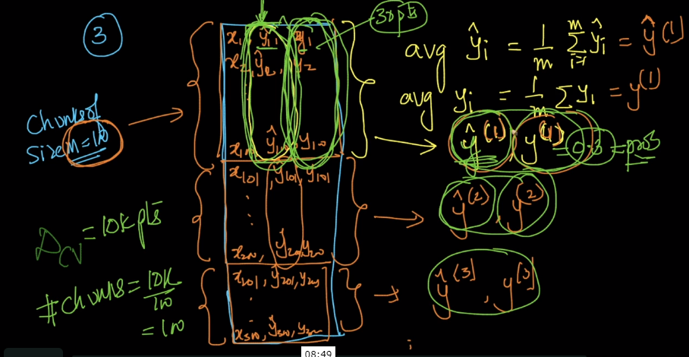

So from this we Data for calibaration i.e Dcalib.

Where y(i) is probability of yi = 1 given xi

And y^(i)is avg of f(xi)

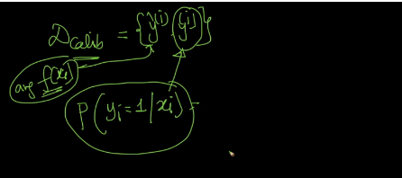

Now we plot calib plot on x axis y^(i) and on y axis y(i) now if both y^(i) ­and y(i) are same then all points lie in orange line i.e 45o line and then we don’t need to do calibaration on model

But it’s not happen in real world model because models doesn’t give actual probability therefore points doesn’t come on line and we have to do calibaration 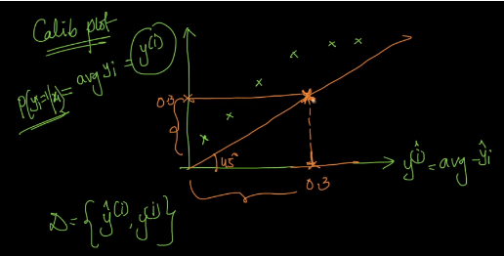

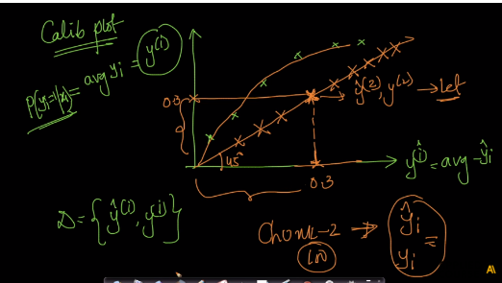

Now we know that we have to do calibaration so how we do is take y^(i) ­ as feature on any linear regression model to predict y(i)i.e predict actual probability

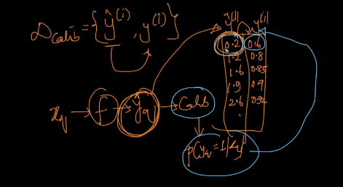

Below image shows that many classification techniques doesn’t gives actual probability.

But one thing is common that all curves are monotonic and it is to be because if our model is sensible then y^(1) ­and y(1) < y^(2) ­and y(2) < y^(3) ­and y(3) < ….

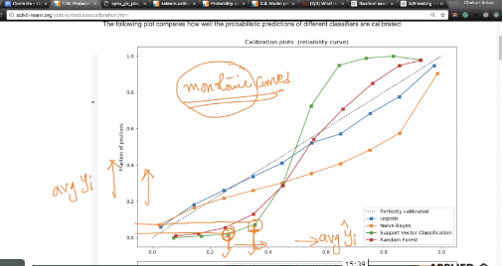

What if we have imbalanced data?

So at the training time we balancing data so that it doesn’t always predict majority pts. Class

And we caliber it on imbalanced cv data i.e we don’t balance data to get the actual probability of the class.

**Note:**

1. If a point comes below a 45o then it means the predicted value is over predicted.
2. If a point comes above 45o then it means that the predicted value by model is under predicted.

Links:

<https://machinelearningmastery.com/calibrated-classification-model-in-scikit-learn/>